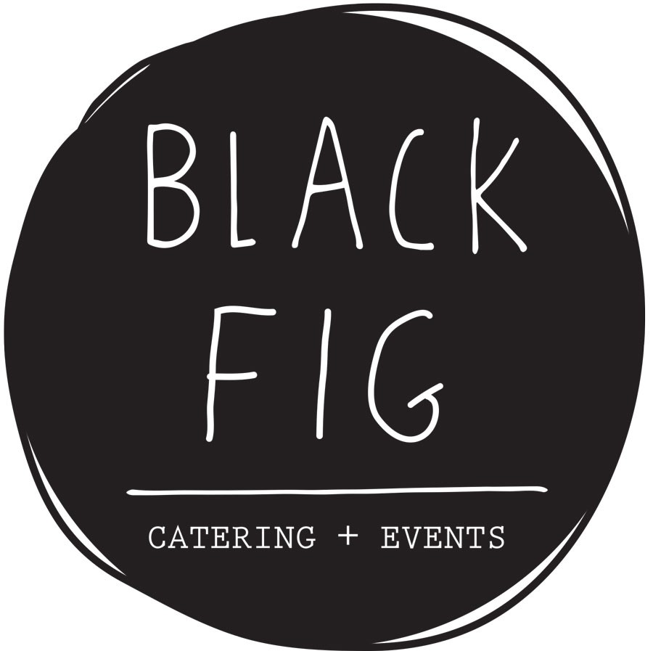
Black Fig Catering + Events January 2024
167 Wainui Rd
Gisborne
Ph: 021 853 794
amy@blackfig.co.nz
Conference Menu Idea’s - Finger Food Style
All prices EXCL GST

Breakfast:
- Ham, Cheese and Tomato Croissants $6 each
- Breakfast Burrito’s with Scrambled Egg, Bacon and Green Tomato Chutney $8 each
- Homemade Muesli Cups with Yoghurt and Fresh Fruit $7 each
- Chicken, Cranberry, Rocket and Brie Panini $8 each
- Overnight Bircher Muesli $7 each
- Bacon and Egg Muffin Split $6 each
- Breakfast Ciabatta Pocket – (Bacon, Egg, Rocket, Mushroom and Chutney) $8 each
- Breakfast Muffin Selection – Sweet and Savoury $5 each
- Homemade Waffles with Banana + Cream or Bacon and Maple $8 each
- Fresh Fruit Salad $5 per cup
- Danish Selection $3 each or 2 for $5
- Chia Pudding with Cononut and Blueberries $6 per jar

Morning Tea:

- Muffin Selection or Scone Selection– sweet or savoury $5 each
- Spinach, Feta and Corn Tartlet’s $5 each
- Homemade Sausage Roll’s $5 each
- Brioche Scrolls – Sweet or Savoury $6 each
- Club Sammy’s $5 for 2
- Mixed Fruit Basket $5 per person
- Mixed Sweet Platter $5 per person
- Gluten Free Friands $5 each
- Vegan Slice $6.50

Lunch:

- Ploughman’s Sammy Selection $5 each
- Wrap Selection (Ham, beef or chicken) $5 each
- Beef, Chicken or Ham Filled Roll Ciabatta Roll $6 each
- Individual Spinach and Feta Spanokopita $6 each
- Homemade Pumpkin, Spinach and Feta Quiche $5 each
- Bacon and Egg Pie $6 each
- Chicken, Cranberry and Brie Toasted Panini $7.50 each
- Toasted Turkish Bread with Pastrami, cheddar and Pickle $7 each
- Quinoa, Spinach and Three Cheese Tart (GF) $6 each
- Homemade Sausage Roll with Chutney $5 each
- Gluten Free Spinach, Feta and Corn Quiche’s $5 each
- Pot freshly made Daily Soup served with Freshly Baked Bread $8 per head
- Kumara, Thyme and Brie Frittata $6.50 each
- Fresh Salad Box’s – selection of 3 salad’s $12 per box
- Vegan Slices $6.50 each
- Vietnamese Rice paper Rolls with Dipping Sauce (chicken, prawn or vegetarian) $6 each
- Mixed Cake Selection $5 per head
- Mixed Sweet Platter $5 per head
- Mixed Fruit Platter $5 per head

Afternoon Tea:

- Club Sammy’s $5 per head
- Homemade Cake Selection ie Carrot Cake, Banana Cake, Lemon Yohhurt Cake, Chocolate Cake $6 each
- Cookie Selection $5 each
- Homemade Brioche Scrolls – Sweet or Savoury $6 each
- Freshly Baked Slider’s wither one of the following – pulled pork, fresh fish, beef or chicken $5 each
- Mixed Fruit Basket $4 each
- Gluten Free Friands $5 each
- Freshly baked scones with cream and jam $5 each

These are just examples and we are happy to cater to your needs and budget.
A delivery fee of $15 applies to all deliveries in the Gisborne city limits.
All platter’s must be returned within 48 hours otherwise a charge of $50 per platter will apply.

